Sepsis Prediction and post operation report generator

Eavam Margamwar   
C.S.E  
Symbiosis Institute Of TechnologyNagpur , India  
eavam.margamwar.btech2023@sitnagpur.siu.edu.in

Siddhesh Mawale  
C.S.E  
Symbiosis Institute Of TechnologyNagpur , India  
siddhesh.mawale.btech2023@sitnagpur.siu.edu.in

Tanmay Kalinkar  
C.S.E  
Symbiosis Institute Of TechnologyNagpur , India  
tanmay.kalinkar.btech2023@sitnagpur.siu.edu.in

***Abstract* — The rise of chronic diseases and the increasing demand for proactive healthcare have necessitated the development of a smart health-monitoring system that can provide continuous health assessments for individuals. Preventing and managing illnesses using technological means have emerged as one of the most pressing challenges facing the medical community. Contemporary lifestyles present significant obstacles to maintaining a healthy routine. AI has been integrated into the field to develop the new domain of smart healthcare. The Internet of Things (IoT) and Artificial Intelligence (AI) are two of the most rapidly emerging technologies. This system collects data through wearable sensors and medical devices, performs data analysis to detect abnormalities, generates reports for patients and their consented doctors, and integrates advanced technology for health monitoring and medication management. It continuously tracks vital signs, such as heart rate, ECG, and temperature, sending immediate alerts to caregivers and medical professionals upon detecting abnormalities. Integrating Generative AI enables patient interaction through a chatbot, allowing patients to inquire about possible health conditions based on their symptoms and receive insights on potential threats. Patients are provided with personalized recommendations for therapy, lifestyle modifications, and care plans by clinical decision support systems after thorough analysis of each element. This paper details the system's architecture, data acquisition methods, and AI models employed, along with the role of Generative AI in enhancing user interaction and healthcare personalization.**

***Keywords—Artificial Intelligence, Machine Learning, Generative AI, Health Data Analysis.***

1. **Introduction:**

Physical and mental well-being are essential to every human being. The absence of disease and enhancement of one's physical and mental well-being are two of the hallmarks of good health, which is a significant benefit. The health and healthcare systems in every culture are becoming more modern and technologically advanced. Intelligent healthcare systems utilize remote nursing of patients to prevent the spread of disease and maximize the efficiency of healthcare spending. The opportunities that AI offers to the smart healthcare field are: [1] predictive healthcare modeling, which involves processing and analyzing data at scale, recognizing patterns, detecting anomalies, making dynamic predictions, and supporting decision making[2]. A viable option in this context is the combination of machine learning and IoT-enabled healthcare systems [3]. Traditional approaches, which rely on manual monitoring and periodic check-ups, may fail to detect early signs of complications. This system employs AI and ML for continuous monitoring and analysis of health data, enhancing the detection of adverse health conditions[4]. Patients' records are organized in a standardized manner to facilitate reliable filing and retrieval of data necessary for their care. Systems of traditional healthcare have been superseded by systems of digital healthcare due to smart IoT-based applications such as devices and smart mobile phone healthcare systems[5]. Consequently, the establishment comprehensive healthcare surveillance networks across the country is becoming prevalent[6]. The raw data from sensors is processed and analyzed using advanced AI and ML algorithms. This layer identifies patterns, detects anomalies, and predicts potential health risks. The system can also monitor trends over time to detect gradual health changes that may indicate emerging conditions[7]. The chatbot utilizes Generative AI to interpret the patient's symptoms and suggest potential conditions based on medical knowledge and health data analysis. Patients can inquire about symptoms such as fatigue, chest pain, or dizziness, and the chatbot responds with possible conditions and recommendations for further medical consultation[8]. In this context, we have developed a platform in which patients' health conditions are analyzed and monitored on a daily basis to identify any abnormal patterns and health improvement using Gen AI and ML.

1. **AI and ML models for health Analysis:**

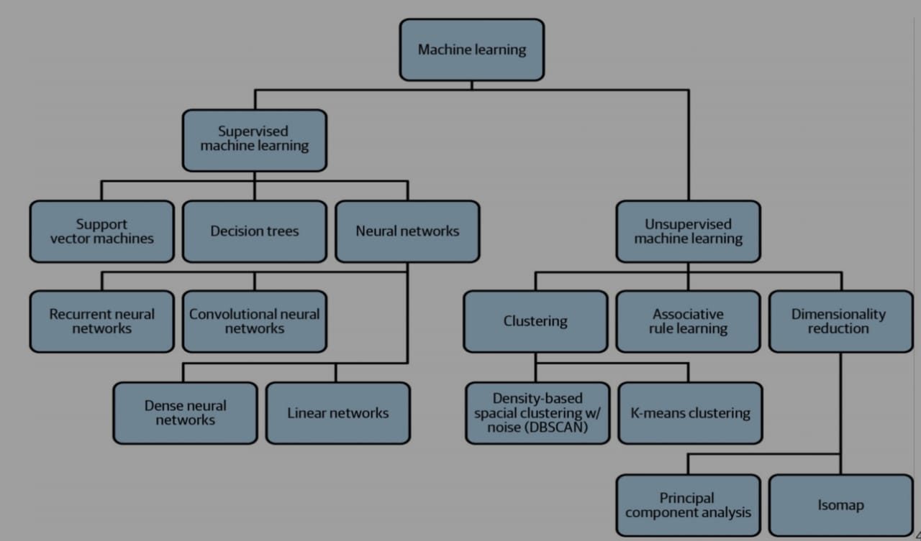

* 1. **Supervised Learning:**

In supervised learning, we require the help of previously collected data in order to train our models. A model based on supervised learning would require both previous data and the previous results as input. By training with this data, the model helps in predicting results that are more accurate. Also, the data, which we use as input data, is also labelled in this case. If an algorithm has to differentiate between fruits, the data has to be labelled or classified for different fruits in the collection. The data is divided into classes in supervised learning. Supervised learning has methods like classification, regression, SVM, KNN, decision tree, etc. Supervised learning is a category of machine learning that uses labeled datasets to train algorithms to predict outcomes and recognize patterns.

**2.1.1 Decision Tree:**

Decision trees are flowcharts that represent the decision-making process as rules for performing categorization. Decision trees start from a root and contain internal nodes that represent features and branches that represent outcomes. As such, decision trees are a representation of a classification problem.Decision trees can be exploited to make them easier to understand. Each decision tree is a disjunction of implications (i.e., if–then statements), and the implications are Horn clauses that are useful for logic programming. A Horn clause is a disjunction of literals.On the basis that there are no errors in the data in the form of inconsistencies, we can always construct a decision tree for training datasets with 100% accuracy. However, this may not roll out in the real world and may indicate overfitting, as we will discuss.

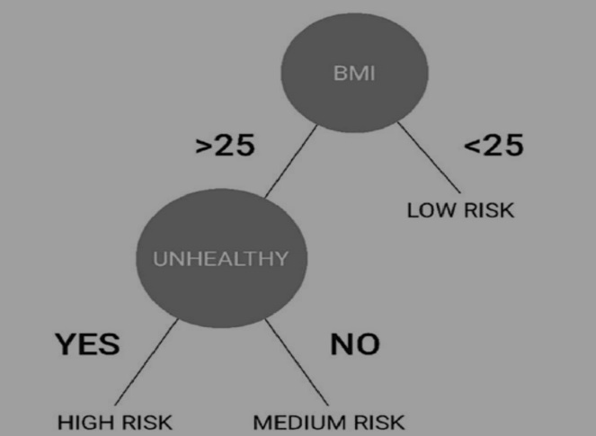

**2.1.2 Support Vector Machines (SVM):**

Support vector machine (SVM) is a non probabilistic binary linear classifier used with both classification and regression problems. SVM is often used along with NLP methods to analyze text for topic modeling and sentiment analysis. It is also used in image recognition problems and handwriting digit recognition .The algorithm finds a hyperplane, or line of best fit, between two classes determined by the support vectors. Support vectors are the data points nearest the hyperplane that would alter the position of the hyperplane if removed. The greater the margin value, or distance from the data points to the hyperplane, the more confidence there is that the data is appropriately classified. The line of best fit is learned from an optimization procedure that seeks to maximize the margin. SVM uses something known as kernelling to map data to higher-dimensional feature spaces. Data is mapped using the kernel trick in iteratively more dimensions until a hyperplane can be formed to classify it. 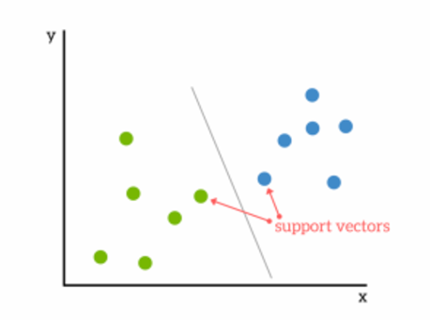

**2.1.3 Neural Networks:**

The biological mechanism in which the brain works inspires artificial neural networks, a different paradigm for computing, based on the parallel architecture of animal brains. Neural networks are well equipped for data mining tasks due to their ability to model multidimensional data and efficiency at finding hidden patterns among data. Neural networks can be applied to prediction and classification problems. The process of estimating the result and comparing it with the real output is known as forward propagation.

**2.2 Unsupervised Learning:**

Unsupervised learning needs no previous data as input. It is the method that allows the model to learn on its own using the data, which you give. Here, the data is not labelled, but the algorithm helps the model in forming clusters of similar types of data. Techniques like clustering and anomaly detection help identify unusual patterns that may indicate health risks.

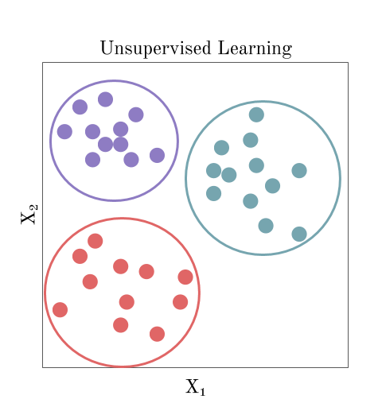

* 1. **Generative AI Integration:**

Gen Al is a subset of Deep Learning, focuses on creating models capable of generating new content that resemble existing data. A Transformer-based model is used to simulate possible disease progressions and provide patient-specific recommendations. The transformer model captures health events (daily vitals, symptoms, and laboratory results) and predicts disease progression. Creates a map of possible future health conditions based on historical data and makes recommendations tailored to the patient’s situation, such as suggesting additional tests or specific precautions. This activates the monitoring system, which is aimed at preventing complications before they occur.

1. **Applications:**

**3.1 Disease Prediction and Prevention:**

AI applications in smart healthcare play a crucial role in predicting and preventing diseases such as dibeties, liver disease and cancer, utilizing SVMs as an ML method and CNNs as a DL method. These AI algorithms analyze EHRs and patient lifestyle data, assisting physicians in interpreting medical images such as X-rays, magnetic resonance imaging, and computed tomography scans. This capability enables more efficient and accurate disease prediction, thereby facilitating effective disease prevention.

Technologies already exist that monitor data to predict disease outbreaks. This is often done using real-time data sources such as social media as well as historical information from the Web and other sources. Malaria outbreaks have been predicted with artificial neural networks (ANNs), analyzing data including rainfall, temperature, number of cases, and various other data points. Many digital technologies offer an alternative to nonemergency health systems. Considering the future, combining the genome with machine learning algorithms provides the opportunity to learn about the risk of disease, improve pharmacogenetics, and provide better treatment pathways for patients.

Additional data was gathered to better comprehend patient demographics, treatment regimens, social networks, and clinical standing. The study showed a significant drop in the number of patients requiring hospitalization (a testament to remote monitoring efficacy).Hospitalization rates were higher for the control group (45.5%) than for the remote healthcare monitoring group (35.6%) across all diagnoses.

**3.1.1 Predictive Analytics:**

Predictive analytics allows us to understand the future and predict the likelihood of a future outcome. It uses the data that you have at your disposal and attempts to fill in missing data with best-guess estimates. It is characterized by techniques such as regression analysis, multivariate statistics, data mining, pattern matching, predictive modeling, and machine learning and uses historical and current data to forecast the likelihood of future events or actionable outcomes.

Predictive analytics skills are in demand as healthcare providers seek evidence based ways to reduce costs, take advantage of value-based reimbursements, and avoid the penalties associated with the failure to control chronic diseases and adverse events that are within their power to prevent. It remains elusive, as it requires access to real-time data that allows near–real-time clinical decision-making.

**3.1.2 Prescriptive Analytics:**

Prescriptive analytics strives to make decisions for optimal outcomes, that is, to use all available data and analytics to inform and evolve a decision of what action to take that is, smarter decisions. Prescriptive analytics attempts to quantify the effect of future decisions to advise on possible outcomes before decisions are made. At its best, prescriptive analytics predicts not only what will happen but also why it will happen to provide recommendations regarding actions that will take advantage of the predictions.

Prescriptive analytics uses a combination of AI techniques and tools such as machine learning, data mining, and computational modeling procedures. These techniques are applied against input from many different datasets including historical and transactional data, real-time data feeds, and big datasets. Prescriptive analytics performs an in-context prediction, taking into account the available evidence. A more useful predictor may integrate the same dashboard with projected costs, real-time bed counts, available education material, and follow-up care. With additional information, clinicians can determine patients with a high risk of readmission and take actions to minimize this risk, resulting in improved patient outcomes and reduced consumption of hospital resources.

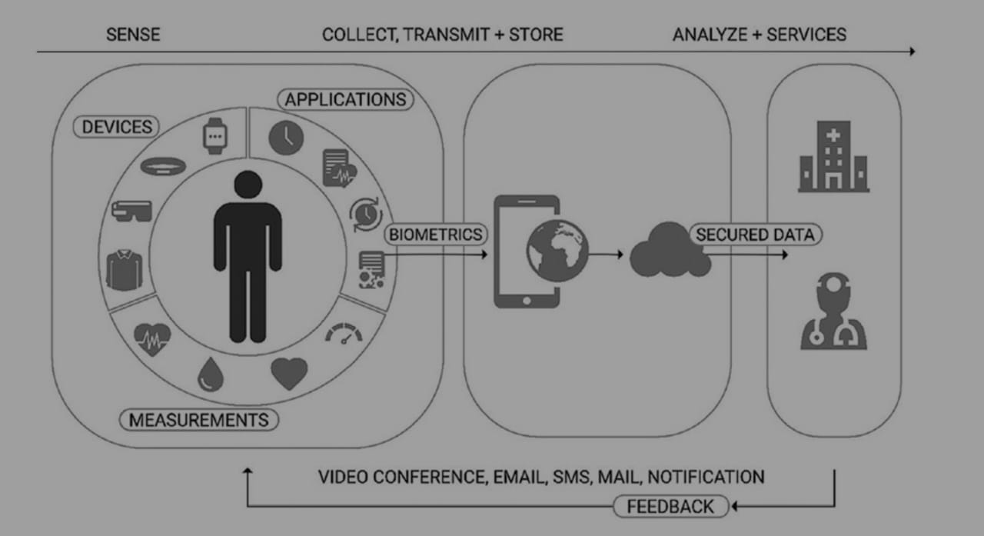

**3.2 Virtual Health Assistant:**

The virtual health assistant is an online platform designed to streamline disease identification for users by providing access to a centralized clinical database in an interactive format. Leveraging NLP technology, it efficiently handles large volumes of user generated natural language data, including text and audio. For pattern recognition and Future Internet classification problems, the SVM classifier performs best, and XG Boost is used for feature extraction to develop new feature combinations for training the SVM model.

The assistant engages intuitively with users through interfaces, responding to queries, sharing health information, and offering self-care recommendations. It is not merely an information provider but a comprehensive health management tool. Additionally, the virtual health assistant shows great potential in managing chronic diseases. For instance, for diabetic patients, it can track blood glucose levels, diet, and physical activity, offering personalized advice to optimize health management. Real-time interaction and continuous monitoring help to improve patient adherence to treatment and overall health outcomes.

1. **Basics Of Artificial Intelligence And Machine Learning:**

Known as AI, artificial intelligence is a broad area of computer science majorly developing machines to perform tasks that heavily involve purely human abilities. Such tasks include perception, reasoning, decision-making, and learning. AI systems process large volumes of data, identify patterns, and predict or recommend, a factor increasingly being applied in various sectors, such as healthcare and finance, and robotics. For example, allowing the autonomous operation in an AI-driven system can ensure to solve problems without human intervention in the real world.

Machine Learning (ML) is a major area in the AI research space, focusing on endowing the computer with the ability to learn from data and reach decisions or predictions without necessarily being explicitly programmed for every task. ML algorithms are data-driven approaches, which handle the relationship as well as the patterns but aim to generalize them to new, unseen data, thereby making it very useful in dynamic domains and data-intensive domains.

**Major Approaches in Machine Learning**

**Supervised learning**: Learn a model given labelled data; input, along with the known output, the model maps inputs to their corresponding outputs, making supervised learning a good candidate for classification tasks (diagnosis of diseases) as well as regression tasks (health metrics forecast).

**Unsupervised Learning**: Here, the model deals with unlabeled data; hence, it determines patterns or groupings in which the final classification exists without a predefined label. Some common applications include clustering, for instance, grouping similar patients, and dimensionality reduction, often used to analyze high-dimensional data, such as genetic or imaging datasets.

**Reinforcement Learning**: In this, an agent learns through interaction with an environment and gets rewarded or penalized appropriately. Reinforcement learning is particularly well suited to problems requiring long sequences of decisions, like robotics or individualized treatment planning.

**Deep Learning**: Deep learning is a form of ML. It leverages many complex neural networks with several layers for modeling highly complex patterns. Models from deep learning are usually best suited for processing unstructured data, for example, medical images and voice recordings that are common in most applications within healthcare.

1. **Challenges:**

In the healthcare domain, the opacity of AI applications during decision-making processes is a significant concern. Although AI technologies such as machine learning (ML) and deep learning (DL) possess powerful capabilities, they often fail to explain their predictions, making their decision-making processes appear as “black boxes” that are difficult to interpret. This lack of transparency can lead to distrust among healthcare professionals and patients regarding AI decisions. For instance, an AI system might provide a diagnostic result without a clear explanation supporting it, making it challenging for doctors to verify or understand the basis of the AI’s judgment. Consequently, healthcare professionals continue to rely on evidence-based diagnoses, and patients struggle to build trusting relationships with their providers. Therefore, it is essential to develop more interpretable AI models to address the opacity in AI decision making, such as by explaining the rationale behind model decisions and the importance of features, thereby enhancing the transparency and trustworthiness of decisions. In the healthcare field, scalability presents a significant challenge for deploying artificial intelligence (AI) solutions Figure 7. While AI applications may perform optimally in small-scale clinical evaluations with a limited data pool, they may face substantial difficulties in maintaining diagnostic accuracy and operational speed when the scope expands to a national healthcare framework.

Healthcare data is highly sensitive, and protecting the privacy of users is a major concern when collecting and transmitting data from wearable devices .The large number of interconnected devices and networks in IoT-based healthcare systems creates multiple attack vectors for cybercriminals. These devices are often vulnerable to malware attacks, phishing attacks, and other cyber threats. Additionally, AI models themselves may be vulnerable to adversarial attacks, which involve subtle modifications to input data that can lead to incorrect predictions or compromise patient privacy, often escaping human detection. These security concerns highlight the need for robust security measures and protocols to protect patient information and ensure the integrity of AI-driven healthcare systems.  
  
Health conditions and lifestyles of individuals can change over time, meaning that the AI/ML models need to adapt continuously to remain effective. Designing systems that can learn from new data and adjust predictions dynamically, without requiring frequent retraining or manual intervention, is a challenge. In time-sensitive healthcare applications ,where entities such as physicians, hospital rooms, and medications exhibit continuous changes over time, continual learning holds great promise, yet its application remains relatively unexplored.   
  
Despite the advantages of AI-driven health monitoring, some users may be hesitant to adopt these technologies due to concerns about data privacy, trust in AI, or discomfort with wearable devices. Encouraging user engagement, especially over the long term, can be difficult, and developing user-friendly interfaces is crucial for widespread adoption.

1. **Future Scope and Development:**

**1. AI-Driven Predictive and Preventive Healthcare:** The future scope and development of a smart health monitoring system using AI and Machine Learning are vast, driven by advancements in technology, increasing demand for personalized healthcare, and the growing role of data-driven solutions in healthcare. As AI and Machine Learning models become more advanced, future systems will focus not just on monitoring health metrics but also on predicting potential health issues before they occur. Predictive models will evolve to identify long-term health risks based on historical data, lifestyle patterns, and genetic predispositions. AI-driven predictive and preventive healthcare is a rapidly advancing area focused on leveraging artificial intelligence (AI) and machine learning (ML) to anticipate and mitigate health issues before they manifest as serious conditions. Unlike traditional healthcare, which is often reactive (treating diseases after they appear), AI-based predictive healthcare uses data-driven approaches to predict potential health risks and empower both patients and healthcare providers to take preventive actions. This shift has the potential to transform the entire healthcare system by improving early diagnosis, reducing hospital admissions, and enhancing overall patient outcomes.

**2.** **Enhanced AI Algorithms and Explainable AI (XAI):** The development of more sophisticated AI algorithms, particularly those that can interpret data from multiple sources in real-time, will be critical for enhancing the accuracy and reliability of health predictions. Moreover, Explainable AI will play a significant role in making the decision-making process of AI models more transparent and understandable to both patients and healthcare providers. As AI-driven healthcare systems become more prevalent, the enhancement of AI algorithms and the development of Explainable AI (XAI) have emerged as critical areas of focus. These advancements are aimed at improving the accuracy, transparency, and trustworthiness of AI models used in healthcare, addressing the need for both high-performance predictions and understandable, interpretable decision-making processes. The integration of sophisticated AI algorithms with explainable frameworks has the potential to significantly improve patient care, regulatory compliance, and adoption by healthcare providers.

**3. Generative AI for More Human-Like Interaction:** Generative AI, as part of smart health monitoring, will continue to evolve and deliver more natural, human-like interactions between users and their health monitoring systems. Future development could focus on expanding the chatbot’s ability to understand and respond to a wider range of symptoms and medical conditions. Future chatbots will use Natural Language Processing (NLP) to engage in more in-depth, contextual conversations with users, offering more nuanced and accurate responses to health queries. AI systems could be designed to detect emotions in a patient’s voice or text input, allowing for more empathetic and supportive interactions, which could be particularly useful for mental health monitoring and intervention.

**4. Real-Time Health Intervention and Automation:** Future systems will go beyond health monitoring to provide real-time interventions, leveraging automation and AI to manage critical situations autonomously. AI can trigger real-time alerts to emergency services or caregivers if it detects life-threatening conditions like heart attacks, strokes, or respiratory failure, potentially saving lives by reducing response time. Integration with wearable or implantable drug delivery systems (e.g., insulin pumps) could allow the system to autonomously administer medication based on real-time health data, such as glucose levels in diabetics. These developments can only occur with the advancement in technology , which in today’s daily life is only imaginable.

1. **Conclusion:**

The development of smart health monitoring systems using AI and Machine Learning has the potential to revolutionize healthcare by providing continuous, real-time monitoring and personalized care. This research paper highlights the role of AI and ML in transforming post-surgical and general health management by leveraging wearable sensors, IoT devices, and advanced algorithms to track vital signs, detect abnormalities, and provide actionable insights. The integration of Generative AI for patient interaction further enhances patient engagement and facilitates more effective communication between patients and healthcare providers.

However, challenges such as data privacy, algorithm explainability, and the need for larger, more diverse datasets remain to be addressed. Future developments should focus on improving algorithm accuracy, enhancing patient-centered interfaces, and ensuring robust privacy measures. As AI and ML technologies continue to evolve, smart health monitoring systems will play an increasingly pivotal role in healthcare, offering scalable solutions for personalized, efficient, and proactive health management.

In this paper, we examined the integration of AI in smart healthcare, emphasizing its evolution from traditional to patient-centric models. We discussed the opportunities that AI brings to the smart healthcare field and its widespread applications. Additionally, we analyzed the challenges faced in this domain along with existing solutions. Ultimately, the conclusion underscores that the benefits of AI outweigh these challenges, signaling a promising future for AI in addressing the complex demands of healthcare.

1. **References:**